Final Product Testing

Final product testing will be carried out on the proof-of-concept mega:bits which use the HT16K33 LED matrix drivers. This was done as time did not allow for full debugging of the IS31FL3737 chip.

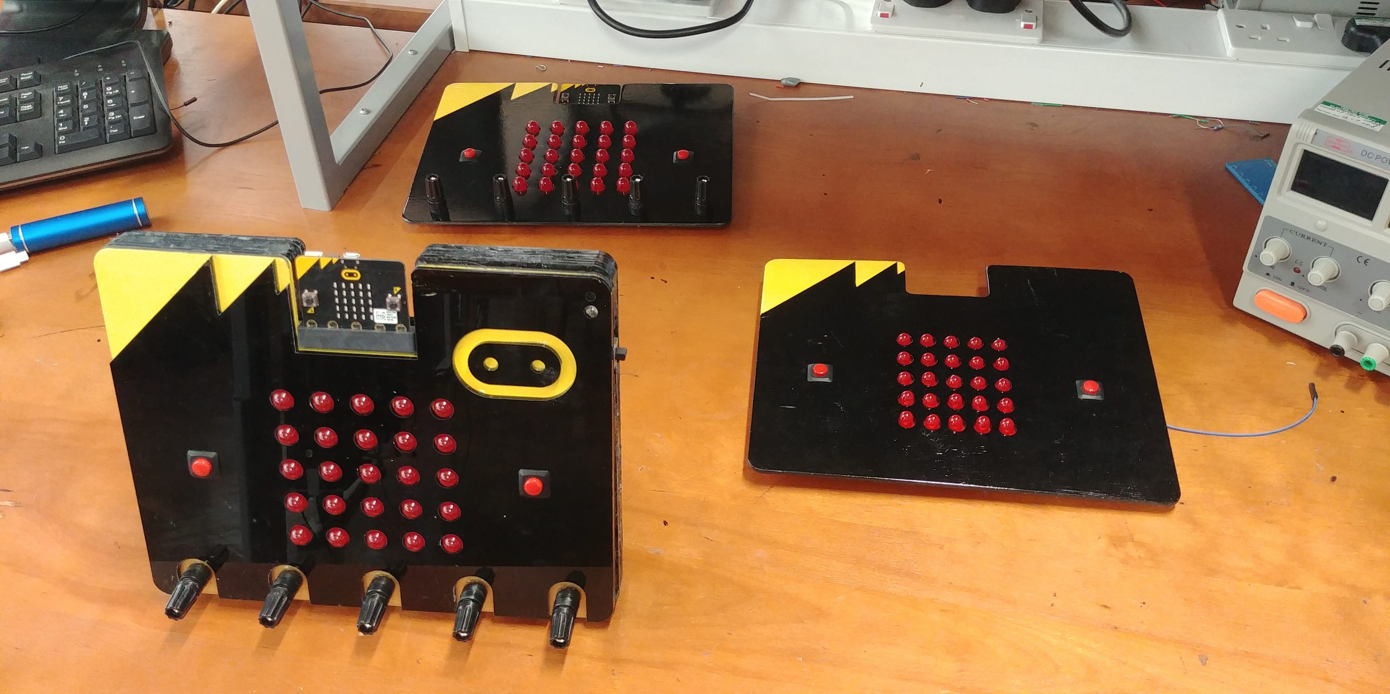

In this document we will explain our testing and analysis which was done using a Keysight oscilloscope.

## I2C Analysis

Figure xxx shows an example output of the I2C communication, the green trace shows the clock signal (SCL) and the yellow trace shows the data signal (SDA).

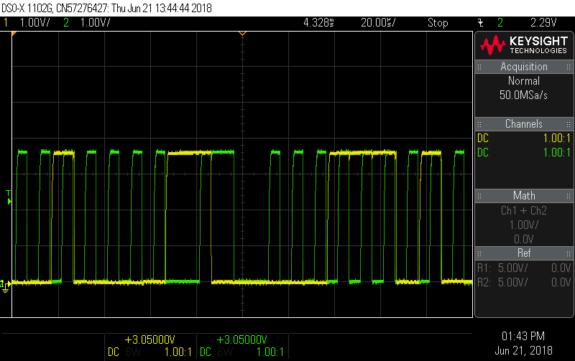

Figure xxx shows the startup I2C communication sequence which includes three transmissions setting the following:

1. Turning on the display oscillator
2. Setting the blink rate to 0
3. Setting the brightness to full

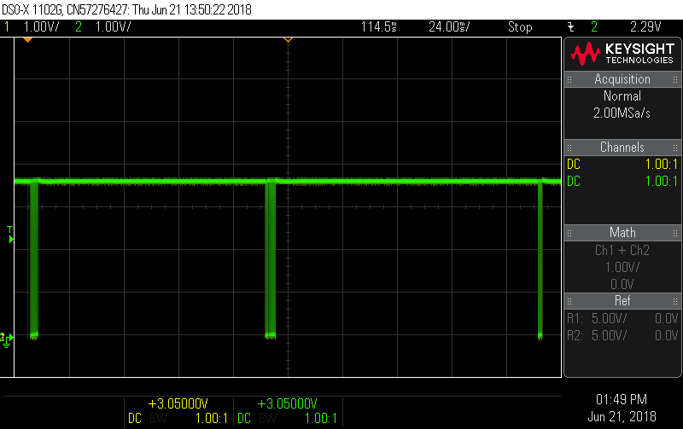

Figure xxx shows a single I2C transmission which is setting the display to show an image. As can be seen from the figure, it is 1.8ms long.

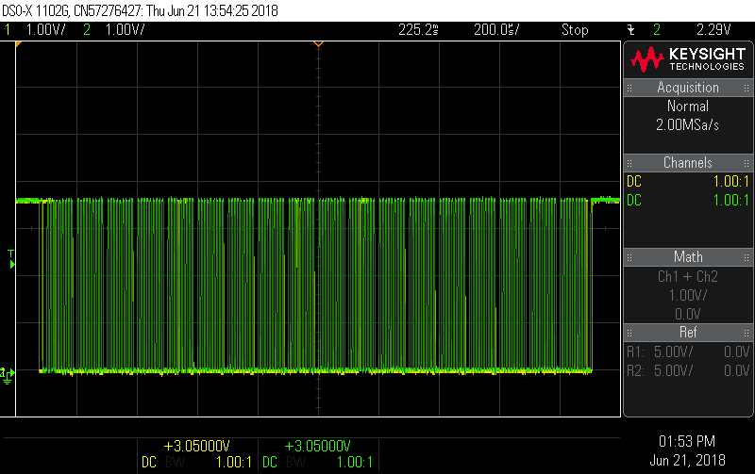

## Handshake Analysis

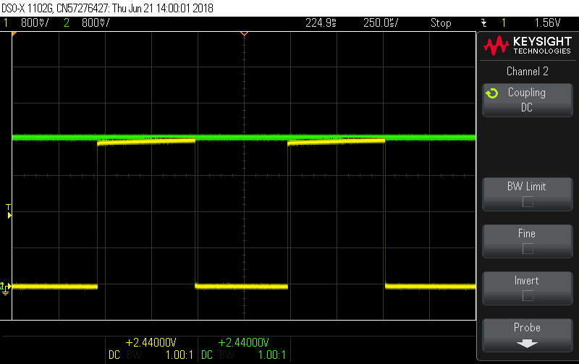

## Display Tests

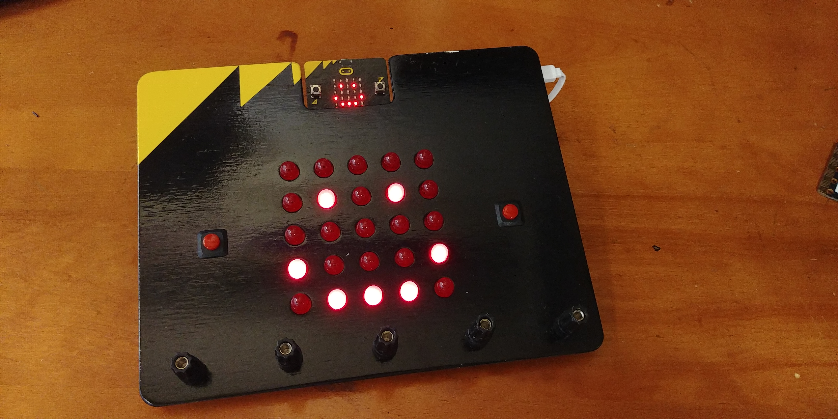

## Distance Tests

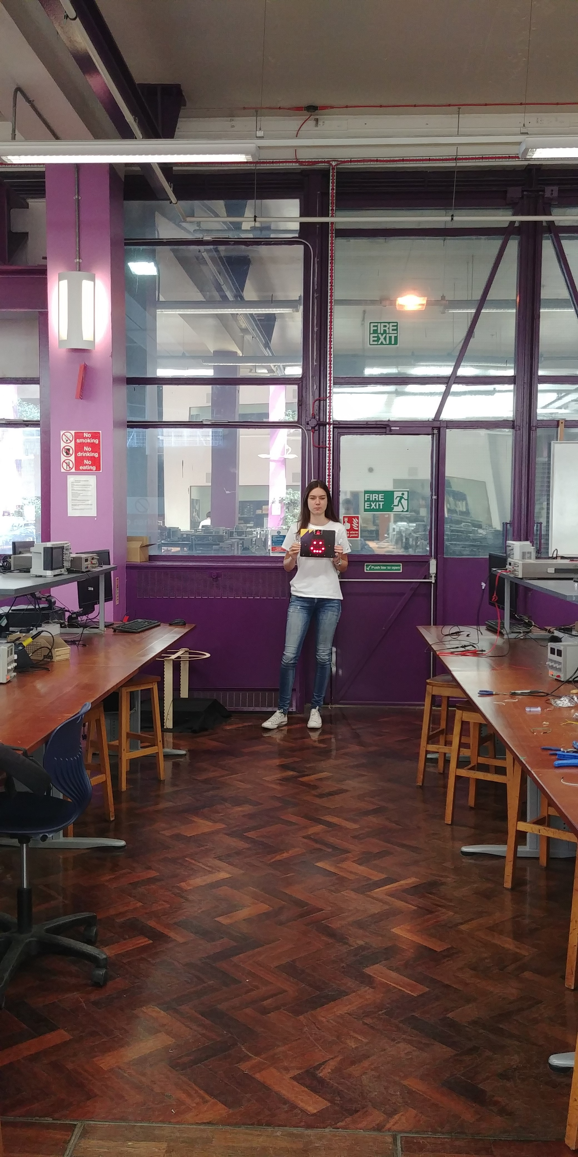

## Short Circuit Tests

